28th ANNUAL BREED SANCTIONED SHOW
Open & Youth

SATURDAY, APRIL 3, 2004

Tippecanoe County Fairgrounds
1401 Teal Road
Lafayette, Indiana
Swine Barn - heated

8:00 AM (EST) Entry Deadline • Show Time 9:00 AM (EST)
Entry Fees - $2.50 class $1.00 Fur
JUDGES:
✶ Kyle Cunningham  John Grimm  Brian Hartzell 
✶ Dave Hauser  Bruce Ormsby  Bill Patrick  Cathy Patrick 
✶ Ron Riddle  Randy Waggoner  Phil Woollet  Mike Young 

OPEN SHOW SUPERINTENDENTS: Max Harrison, jr. and Bryan Foulks

YOUTH SHOW SUPERINTENDENTS: Travis Poe and Ashley Broady

SHOW SECRETARY: Carl Broady (Open) Ashley Broady (Youth)
4921 Hawthorne Ridge, West Lafayette, IN 47906
765-463-6111 or broadybunch@yahoo.com

WE WELCOME THE FOLLOWING
SPECIALTY SHOWS:

✶ INDIANA ANGORA RBSC – Bill Patrick 
✶ TRI-STATE HIMALAYAN RC – Bill Patrick 
✶ INDIANA STATE DWARF RBC – Brian Hartzell 
✶ INDIANA STATE MINI REX CLUB – Cathy Patrick 
✶ HOOSIER HOLLAND LOP CLUB – Randy Waggoner 
✶ SYCAMORE SATIN ASSOCIATION – Kyle Cunningham 

SHOW RULES

1. This show is to be governed by the latest rules of the ARBA, and filing of entry indicates acceptance of same.
2. The GPRBA will not be responsible for loss from Fire, Theft, Accidents, or Providential Destruction.
3. Specials, received too late for listing in this catalog, will be posted in the showroom.
4. The GPRBA reserves the right to substitute or hire additional judges in case of unavailability of the first selection.
5. ENTRY FEE: Single rabbit - $2.50. Fur/Wool entries $1.00. (OPEN and YOUTH).
6. All Fur entries must be shown in their respective BREED class.
7. This is a carrying case show only. ALL cases MUST BE solid bottomed.
8. No diseased or unsightly animals will be permitted in the showroom. Such animals will be removed from the showroom at the discretion of the Show Superintendent.
9. ALL stock must be Permanently and LEGIBLY tattooed in the left ear.
10. All rabbits, both Open and Youth, must be entered by 8:00 a.m.
11. Ribbons will be awarded through 3rd Place, and must be picked up the day of the show. Rosettes will be awarded for Best and Best Opposite of Breed for those breeds with 10 or more entered. NO RIBBONS WILL BE MAILED.
12. The GPRBA will award plaques for Best Six Class, Best Four Class, and Best In Show. (Open and Youth)
13. No payback other than those required.
14. An ARBA Registrar will be available. If you wish to have your animals registered, bring your ARBA membership card and pedigrees.
15. No shipped in rabbits will be accepted.
16. Please use the ARBA entry forms and remark cards provided in the showroom. Software generated entry forms are acceptable.
17. It is the RESPONSIBILITY of the exhibitor to see that entry forms and remark cards are filled out correctly and completely. substitutions are not allowed once judging begins.
18. Any breeds with less than 10 rabbits shown will not be sanctioned the following year unless paid by an exhibitor. Any sanction paid for by an exhibitor with 20 or more rabbits shown will be refunded by the club.
19. The GPRBA is not responsible for catalog errors or omissions.

The Golden Prairie RBA Awards the following Specials:

Best 4 Class - Plaque
Please join us for our Fall show to be held:

October 9, 2004

at the Tippecanoe County Fairgrounds Lafayette, IN

Best 6 Class - Plaque
Best in Show - Plaque
Best of Breed - Open and Youth - Rosettes
$25.00 for Best Display total - Open or Youth

K&D Cage
Company and Supplies
Central Indiana's Most
Complete Supplier

Custom Made and Standard Wire
Cages • Cage Parts and Supplies •
Nesting Boxes • Tattooing Kits •
Nutritional Research Products •
Vitamin Supplements • Wild & Caged Bird
Feed & Supplies • Feeders & Crocks •
Much Much More

Please call ahead
for feed, custom cages, and large orders

1-800-265-5113

Karen & David Snedigar

Country Tee's

812-332-8392
N Tunnel Rd
Uniontown, IN 47468

Show Coats
Show Jackets
T-shirts
Sweatshirts

GPRBA OFFICERS
President - Brad Boyce
Vice President – Bryan Foulks
Secretary/Treasurer - Karen Poe
Show Secretaries - Carl and Ashley Broady

Breakfast and Lunch stand will be provided.

SANCTIONS
Official ARBA Sanctioned Open Show # UOA0193
Official ARBA Sanctioned Youth Show # UYA0115
American Rabbit Breeders Association c/o Glen C. Carr, Secretary • P.O. Box 426 • Bloomington, IL 61702
Dues: 1 Year 3 Years
$15.00 Adult $40.00 Single
$20.00 Husband/Wife $50.00 H/W
$20.00 Family + $2/youth $50.00 Family + $6/youth
$8.00 Youth <18 years $20.00
Sanction Fee: $20.00 Open $10.00 Youth

A Registrar will be present the day of show.

Indiana State RBA Marcia Raab, Secretary • PO Box 49, Sunman, IN 47041
Dues: $6.00 Individual or single $10.00 H/W and $4.00 each youth member through 18 yrs old.
Sanction Fee: $1.00
ISRBA presents the following awards at the ISRBA Convention in September to eligible ISRBA members: 10 Trophies for the breeders with the most Points in the 10 largest breeds shown for the year. 5 Trophies for the most total points all breeds 1 Trophy for the most points out of state breeder. 10 Trophies for the most youth total points all breeds.

Harrison's Hoppers
Himilayans
765/471-8140
RAFFLE - Lots of excellent items available. Tickets .25 each or 5 for $1.00. Any donation will be greatly appreciated. If you plan to donate any live rabbits in the raffle, please provide a carrier.

Broady's Mini Rex
West Lafayette, IN
765/463-6111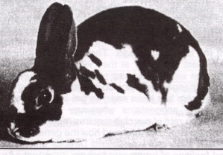
broadybunch@yahoo.com

Broken (black, blue, castor, b/o tri, b/f tri)
Castor, Lynx, Red, White

2004 ARBA Convention
November 14-18, 2004
Providence, Rhode Island

BREEDS SANCTIONED
Oliver Flynn
Hippity Hopp Farm
3440 W 250 N
West Lafayette, IN 47906-5149
Kent Feeds Ambassador
Cinnamon Rabbits
765/463-4616
bsktbunny1@aol.com
Breed | Open | Youth | State
Am. Checkered Giant | X | X
Am. Fuzzy Lop | X | X
Angora, all 4 | X | X | X
Belgian Hare | X | X
Beveren | X | X
Californian | X | X | X
Champagne D’ Argent | X | X
Cinnamon | X | X
Dutch | X | X | X
Dwarf Hotot | X | X
English Spot | X
Florida White  John & Sharon Dwenger's  Florida Whites  765/385-2512 | X | X | X
French & English Lop | X | X | X
Havana | X | X
Himalayan | X | X | Tri-State
Holland Lop | X | X | X
Jersey Wooly | X | X
Mini Lop | X | X | X
Mini Rex  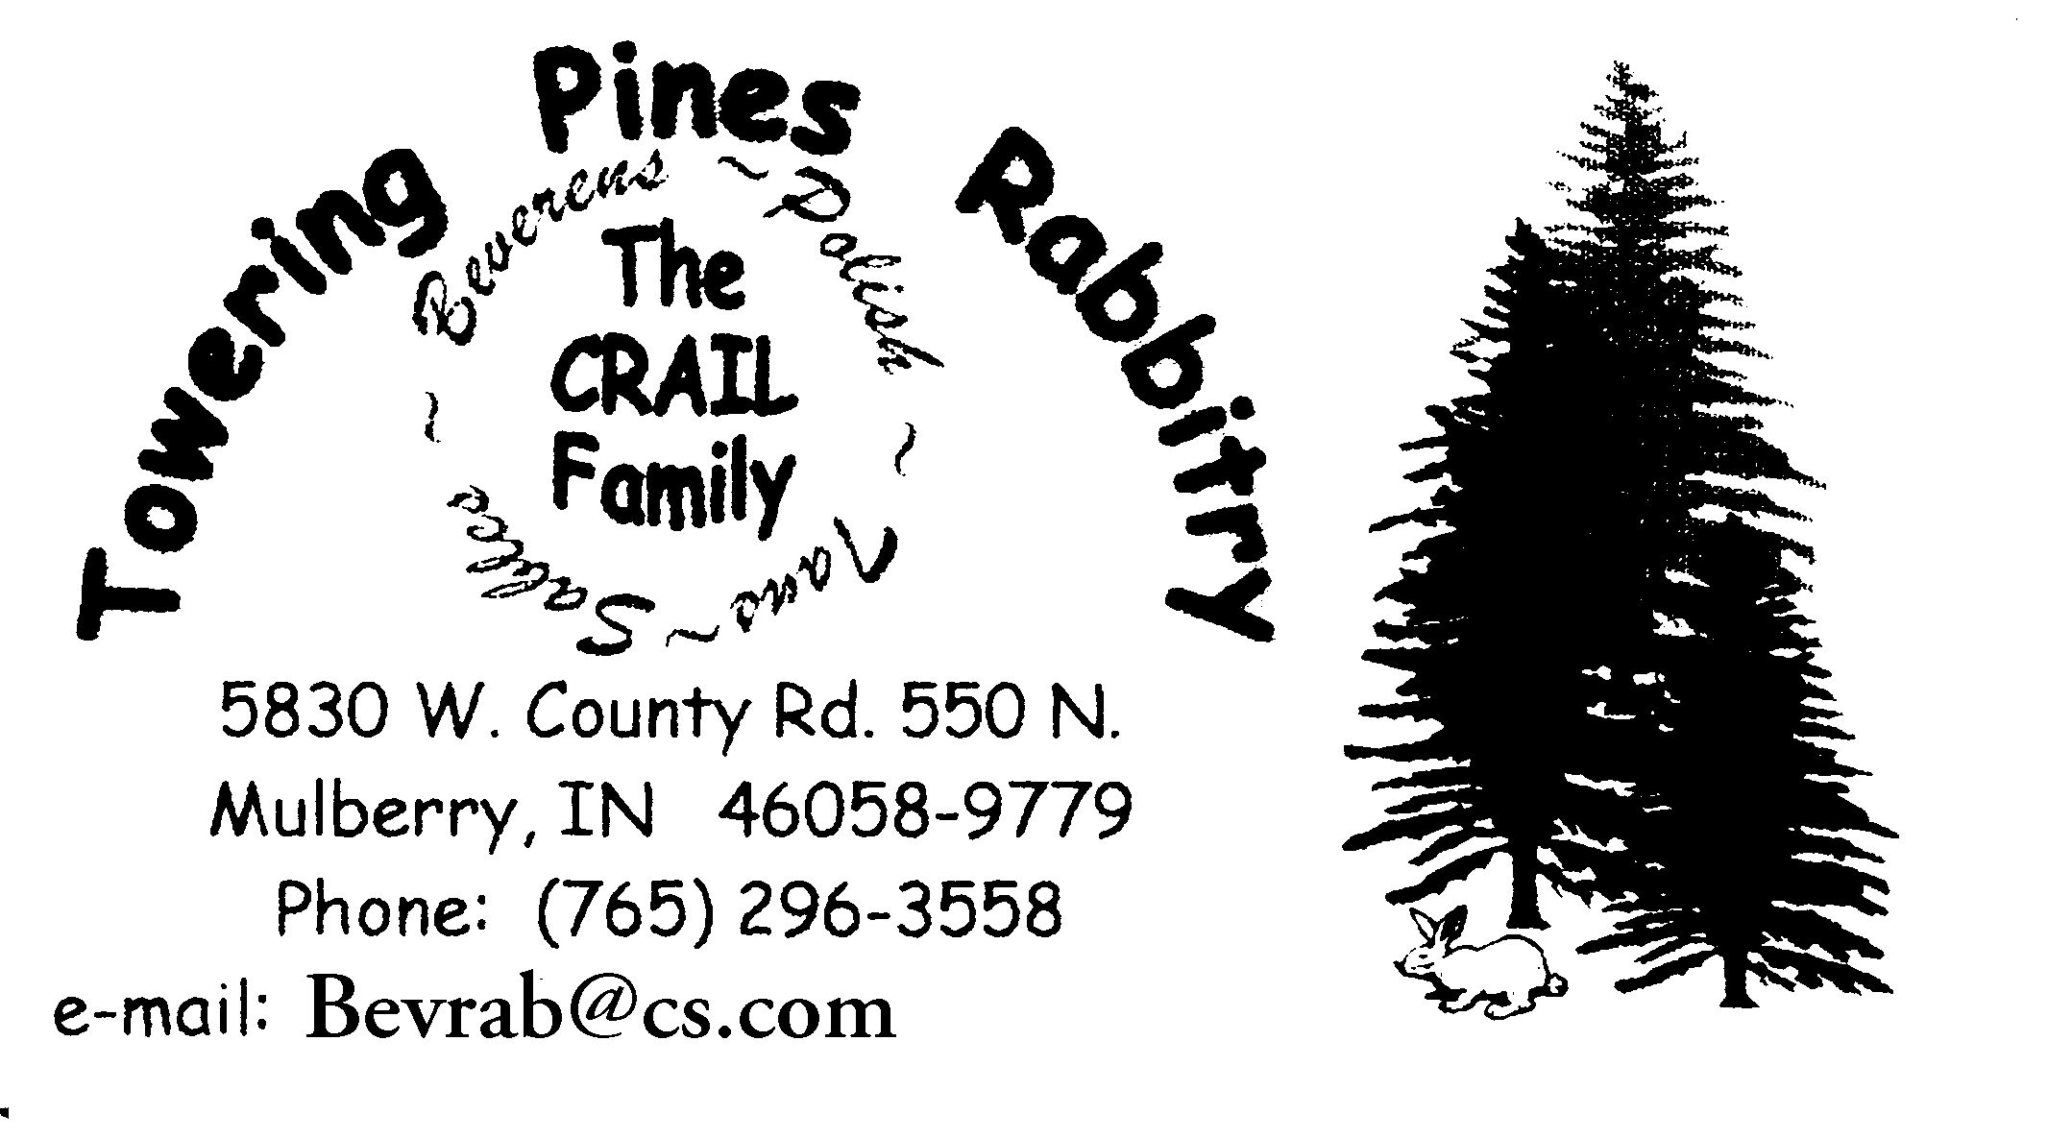 | X | X | X
Netherland Dwarf | X | X | X
New Zealand | X | X | X
Palomino | X | X
Polish | X | X | X
Rex | X | X | X
Rhinelander | X | X
Satin | X | X | X
Silver Martin | X | X
Tan | X | X

STATE SPECIALTYCLUBS SANCTIONED
Official Hoosier Florida White Rabbit Specialty Club Sweepstakes Show Secretary: Sally Mayes 10299 Carpenter RD Bloomingdale, IN 47832
Sanction Fee: $5.00 (includes open & Youth)

Sycamore Satin Association Sanctioned Show
Secretary: Fay Hauser, 3017 E SR 16 Lucerne, IN 46950
Sanction Fees: $5.00 (Includes Youth) Youth Alone $5.00

Hoosier Holland Lop Rabbit Club
Secretary: Carolyn Jock 14747 CR 28 Goshen, IN 46528
Sanction Fees: $5.00

Indiana State Lop Rabbit Club Sweepstake Show
Secretary: Jean Thomas • 3649 E CR 700 S • Cloverdale, IN 46120-8810 Sanction Fee: $5.00 Both Breeds, Youth Free with open

Official Hoosier Dutch Rabbit Fanciers Sweepstakes Show
Secretary: Susan Jock 14747 CR 28 Goshen, IN 46528
Sanction Fees: $5.00 O/Y

Official Indiana Angora Rabbit Breeders Specialty Show
Secretary: Debbie Eldridge • PO Box 19 • Daleville, IN 47334
Sanction Fee: $6.00

Official Indiana State Dwarf Rabbit Breeders Sweepstake Show
Sweepstakes Chairman: Monty Mason, 6200 W 400 S, Glenwood, IN 46133 Sanction Fee: Open $3.00 Youth $2.00.

Official State Of Indiana New Zealand Rabbit Breeders Inc Sweepstakes Show
Secretary: Sherie Raisor • 1309 SR 42 • Mooresville, IN 46158
Sanction Fee: $3.00/Open $2.00/Youth

Official Indiana State Rex Rabbit Breeders Association Show
Secretary: Diana Wiles • 12517 Upas Road • Plymouth, IN 46563 Sanction Fee: $5.00

Official Hoosier Palomino Rabbit Breeders Association Sweepstakes
Secretary: Tim Fitch • 2119 W 450 S • Huntington, IN 46750
Sanction Fee: $7.00 Open $4.00 Youth (Free with paid Open Sanction)

Official Indiana Mini Lop Club Sweepstake Show
Secretary/Treasurer: Judy Todd, 1617Douglas Ln., Lebanon IN 46052 Sanction Fee: $10.00 Open $5.00 Youth

Official Indiana State Mini Rex Club Sweepstakes Show
Secretary/Treasurer: Pam Sherbahn, 404 E Sunset Dr, South Whitley IN 46787. Sanction Fee: $5.00 Open (Youth Included) $5.00 Youth Only

Tri-State Himalayan Rabbit Club
Secretary: Jim Taulbee • 37260 Hocking Dr. • Logan, OH 21754

NATIONAL SPECIALTY CLUBS SANCTIONED

AMERICAN BELGIAN HARE CLUB
Linda Telega, 6456 Spencer Calrk Rd, Fowler, OH 44418-9771
Ph: 330-772-2817 E-mail: LtelegaT@aol.com
Membership: $5.00 - H/W $7.50 - Youth with adult or H/W in same household $2.50.
Sanction Fee: $5.00 Open or Youth
AMERICAN BEVEREN RABBIT CLUB
Pat Vezino, PO Box 65, Sunfield, MI 48890
Ph: 517-566-8218 E-mail: rabbits@centurytel.net
Membership: Adult $5.00 - Two adults living at same residence $7.50 - Youth $3.00 - Family $7.50 plus $2.00 for each youth member - Foreign $4.00 surcharge per residence.
Sanction Fee: Open $7.00 - Youth $5.00
AMERICAN DUTCH RABBIT CLUB, INC
Doreen Bengtson, Rt 1 Box 95, Lewiston, MN 55952
Ph: 507-864-2103
Membersip: (1 yr) Adult $10.00 Youth $8.00 - H/W $14.00 - Family $20.00 - (Canadians add $5.00 per year mailing fee - Foreign add $8.00 per year mailing fee)
Sanction Fee: Open $9.00 - Youth $6.00
AMERICAN DWARF HOTOT RABBIT CLUB
Sharon Toon, 4061 Tremont Ave, Egg Harbor Township, NJ 08234-9421
Ph: 609-641-8839
E-mail: SToon81611@aol.com
Membership: Adult $10.00 - Youth $7.00 - Husband/Wife $15.00 - Family $15.00 + $2.00 per Youth
Sanction Fee: Open $8.00 - Youth $5.00
AMERICAN ENGLISH SPOT RABBIT CLUB
Rosalie Berry, 513 E Kent St, Lubbock, TX 79403-1609
Ph: 806-762-1918 E-mail: berrypatch@att.net
Membership: Adult $10.00 - H/W or Family $13.00 - Youth $7.00
Foreign same as US
Sanction Fee: Open $10.00 - Youth $5.00
AMERICAN FEDERATION OF NEW ZEALAND RABBIT BREEDERS
Sam Rizzo, 32 Church St - PO Box 171, Honeoye, NY 14471-0171
Ph: 585-229-5760 E-mail: SRIZZO124@aol.com
Membership: Adult $14.00 (new) $12.00 (renewal) H/W $16.00 (new) $14.00 (renewal) - Youth $12.00 (new) $7.00 (renewal) Family $27.00 (new) $22.00 (renewal) - Canadian $16.00 (new) $14.00 (renewal) - All other Foreign $40.00
Sanction Fee: Open $12.00 - Youth $8.00
AMERICAN FUZZY LOP RABBIT CLUB
Muriel Keyes, 14255 SE Stephens, Portland, OR 97233
Ph: 503-254-2902 E-mail: MIKEYES@aol.com
Membership: (1 yr) $17.00 new, $12.00 renewal - Family $22.00 + $2.00 per Youth new, $17.00 + $2.00 per Youth renewal - Canada $22.00 - All other Foreign $35.00 - (3 yr) $37.00 new, $32.00 renewal - Family $54.00 + $6.00 per Youth new, $48.00 + $6.00 per Youth renewal - Sanction Fee: Open $10.00 - Youth $6.00.
Sanction requests to: Jennifer Sims, 6410 Mendius Ave NE, Albuquerque, NM 87109 Ph: 505-828-1081 E-mail: LOEAFLML@aol.com

AMERICAN HIMALAYAN RABBIT ASSOCIATION
Errean Kratochvil, 7715 Callan Court, New Port Richey, FL 34654
Ph: 727-847-1001 E-mail: himi1@yahoo.com
Membership: (1 yr) Adult $10.00 H/W or Family $12.00 - Youth $8.00 - (3 yr) Adult $25.00 - H/W or Family $30.00 - Youth $20.00
Sanction Fee: Open $7.00 - Youth $7.00 - Open & Youth combined $10.00
AMERICAN NETHERLAND DWARF RABBIT CLUB
Sue Travis, 326 Travis Lane, Rockwall, TX 75032
Ph: 972-771-4394 E-mail: TravisDwar@aol.com
Membership: (1 yr) Adult: new $15.00 renew $13.00 2 member family: new $20.00 renew $15.00 - Youth: new $10.00 renew $8.00 - 3+ member family: new $25.00 renew $20.00 - (3 yr) Adult: new $40.00 renew $35.00 - 2 member family: new $45.00 renew $37.00 - Youth: new $25.00 renew $20.00 - 3+ member family new $50.00 renew $42.00 - Canada add $8.00 per year - Other Foreign add $15.00 per year (US Funds)
Sanction Fee: Open $15.00 - Youth $10.00 - Sweepstakes Chairperson: David Pett, 17 Ponderey Place, Concord, CA 94521 E-mail: Pettrabbit@aol.com
AMERICAN POLISH RABBIT CLUB
Betty Strathman, 417 Washington Ave, Terrace Park, OH 45174
Ph: 513-831-3176
Membership: Adult or Youth $8.00 - H/W $10.00 Family $12.50 (residing at same address) - Foreign $20.00
Sanction Fee: Open $10.00 - Youth $10.00
AMERICAN SATIN RABBIT BREEDERS ASSOCIATION
Clarence Linsey, 316 South Mahaffie, Olathe, KS 66061
Ph: 913-764-1531 E-mail: clinsey@mnu.edu
Membership: (1 yr) Adult $10.00 - H/W $12.00 - Youth $8.00 - Family $14.00 - (3 yr) Adult $25.00 - H/W $30.00 - Youth $20.00 - Family $35.00 - Foreign add $10.00 per year surcharge
Sanction Fee: Open $10.00 - Youth $5.00
AMERICAN TAN RABBIT CLUB
Virginia Akin, 718 CR 216, Sweetwater, TX 79556
Ph: 325-236-4032 E-mail: tanrbt@aol.com
Membership: Adult new $13.00 - renew $8.00 - H/W new $17.00 - renew$12.00 - Youth new $10.00 - renew $5.00 - Family new $20.00 - renew$15.00 (includes all Youth under 18 yrs) -
Sanction Fee: Open $10.00 - Youth $4.00
CALIFORNIAN RABBIT SPECIALTY CLUB
C. Eunita Boatman, 22162 S Hunter Rd, Colton, OR 97017
Ph: 503-824-2138 E-mail: nitabug@colton.com
Membership: (1 yr) Adult $10.00 - H/W $15.00 - Youth $5.00 - (3 yr) Adult $28.00 - H/W $42.00 Family: $5.00 for 1st Youth $2.00 each additional youth (per year) provided an adult maintains membership also - Canada and Foreign add $5.00 per year.
Sanction Fee: Open $10.00 - Youth $5.00
CHAMPAGNE D’ARGENT RABBIT FEDERATION
Wayne Cleer, 1704 Heisel Ave, Pekin, IL 61554
Ph: 309-347-1347 E-mail: cleerchamp@grics.net
Membership: (1 yr) Adult $10.00 - Husband/Wife $12.00 - Family or Rabbitry $15.00 - Youth $6.00 - (3 yr) Adult $27.00 - Husband/Wife $33.00 Family or Rabbitry $42.00 - Foreign add $10.00 surcharge per year
Sanction Fee: Open $9.00 - Youth $6.00
CINNAMON RABBIT BREEDERS ASSOCIATION
Nancy Searle, 550 Amherst Rd, Belchertown, MA 01007
Ph: E-mail:
Membership: (1 yr) Adult or Youth $4.00 - H/W $ 6.00 - Family $6.00 plus $2.00 each youth; (3 yr) Adult or Youth $11.00 - H/W $16.00 - Family $16.00 plus $6.00 each youth.
Sanction Fee: Open $5.00 - Youth $5.00 (free if requested with Open)

FLORIDA WHITE RABBIT BREEDERS ASSOCIATION
Jane Meyer, 1795 N 1800 E Rd, Thawville, IL 60968 Ph: 217-387-2427
email: arbayuth@illicom.net
Membership: (1 yr) Adult $7.00 - H/W $ 10.00 - Youth $5.00 - (3 yr) Adult $18.00 - H/W $25.00 - Youth $12.00 - Single Life $100.00—Husband/Wife Life $175.00. Sanction Fee: Open $10.00 - Youth $5.00 - Combination $10.00
HAVANA RABBIT BREEDERS ASSOCIATION
Julia Rittenour, 5554 Old State Rd, Whittemore, MI 48770
Ph: 989-469-4533 E-mail: jrpalace@hotmail.com
Membership: (1 yr) Adult $8.00 - H/W $11.50 - Youth $6.00 - Family $11.50 + $3.50 per Youth at same address - (3 yr) Adult $20.00 - H/W $29. 50 - Youth $14.50
Sanction Fee: Open $7.00 - Youth $5.00 Open & Youth combined $10.00
HOLLAND LOP RABBIT SPECIALTY CLUB
Pandora Allen, 2633 Seven Eleven Rd, Chesapeake, VA 23322
Ph: 757-421-9607 E-mail: HLRSCSec@aol.com
Membership: (1 yr) Adult: New $15.00, Renew $10.00 - H/W: New $19.00, Renew $14.00 - Youth: New $12.00, Renew $7.00 - Family: New $22.00, Renew $17.00 - (3 yr) Adult: New $32.00, Renew $27.00 - H/W: New $45.00, Renew $40.00 - Youth: New $23.00, Renew $18.00 - Family: New $54.00, Renew $49.00 - Canadian & Mexico service charge $5.00 (1 yr), $15.00 (3 yr) - All other Foreign service charge $10.00 (1 yr), $30.00 (3 yr)
Sanction Fee: Open $15.00 - Youth $10.00 - Send sanction requests to: Linda Pett, 17 Ponderey Place, Concord, CA 94521 Ph: 510-687-7656 E-mail: Pettrabbit@aol.com
LOP RABBIT CLUB OF AMERICA
Jeanne Welch, PO Box 8367, Fremont, CA 94537-8367
Ph: 510-793-4977 E-mail: LRCAsecretary@aol.com
Membership: Adult $11.00 (new) $8.00 (renewal) - H/W $15.00 (new) $12.00 (renewal) - Youth $10.00 (new) $7.00 (renewal) - 2 or more years (per year) Adult $8.00 - H/W $12.00 - Youth $7.00 - Family $5.00 per youth per year with adult membership - Foreign add $6.00 per year service fee Sanction Fee: Open $12.00 - Youth $6.00
MINI LOP RABBIT CLUB OF AMERICA
Pennie Grotheer, PO Box 17, Pittsburg, KS 66762
Ph: 417-842-3317 E-mail: minilop@tiadon.com
Membership: (1 yr) Adult $15.00 - H/W $ 18.00 - Youth $10.00 - Family $20.00 - (2 yr) Adult $28.00 - H/W $34.00 - Youth $15.00 - Family $38.00 - Foreign add $5.00 per year surcharge. Sanction Fee: Open $12.00 - Youth $6.00
NATIONAL ANGORA RABBIT BREEDERS CLUB
Sharon Vecchiolla, 23 Desiree Dr, Hamilton Square, NJ 08690-2833
Ph: 609-587-6257 E-mail: starzangoras@yahoo.com
Membership: Adult (1 yr) $10.00; (2 yr) $18.00; (3 yr) $27.00 - Youth (1 yr) $5.00 (2 yr) 10.00 (3 yr) $15.00 - Rabbitry 1 yr $15.00 2 yr) $25.00; (3 yr) $35.00 - Family (1 yr) $20.00 (2 yr) 30.00 (3 yr) $40.00 - Canadian add $8.00; all others add $10.00.
Sanction Fee: Open $12.00 all 4 breeds - Youth $5.00 all 4 breeds (Youth free if requested with Open) Send sanction requests to: Debbie Eldridge, PO Box 604, Daleville, IN 47334 Ph: 765-378-0642 E-mail: denantz@yahoo.com
NATIONAL JERSEY WOOLY RABBIT CLUB
Nancy Hinkston, 1311 Poe Lane, San Jose, CA 95130
Ph: 408-241-0383 E-mail: yarnitall@sbcglobal.net
Membership: Adult (1 yr) $14.00 new, $10.00 renewal - (3 yr) $27.00 new, $24.00 renewal - Youth (1 yr) $9.00 new, $6.50 renewal - (3 yr) $21.00 new, $18.00 renewal - Foreign service charge $5.00 per year.
Sanction Fee: Open $10.00 - Youth $5.00
Send sanction requests to: Cynthia Coy, 07861 Huber Rd, Hicksville, OH 43526 E-mail: lostcrk@bright.net

NATIONAL MINI REX RABBIT CLUB
Doug King, 2719 Terrace Ave, Sanger, CA 93657-9195
Ph: 559-787-2588 E-mail: kingsminirex@msn.com
Membership: 1 Yr - Adult $15.00 new, $10.00 renewal - Youth $10.00 new, $8.00 renew - H/W $20.00 new, $15.00 renew - Family $30.00 new, $25.00 renew - Foreign: $ 27.00 new, $22.00 renew.
Sanction Fee: Open $10.00 - Youth $8.00
AMERICAN CHECKERED GIANT RABBIT CLUB, INC
Carol M. Edwards, 542 Aspen St NW, Toledo, OR 97391
Ph:541-336-2543 E-mail: cedwards@harborside.com
Membership: $10.00 for first person at address, all additional at same address $5.00 per person. Sanction Fee: $10.00

NATIONAL REX RABBIT CLUB
Bill Lorenz, 21840 S 116th Ave, New Lenox, IL 60451
Ph: 815-469-5150 E-mail: Rexsecy@aol.com
Membership: (1 yr) Adult or Youth $8.00 H/W $11.00 - (3 yr) Adult or Youth $19.00 - H/W $26.00 - Foreign add $10.00 per year surcharge.
Sanction Fee: Open $10.00 - Youth $7.00
PALOMINO RABBIT CO-BREEDERS ASSOCIATION
Deb Morrison, 396202 W 4000 Rd, Skiatook, OK 74070
Ph: 918-396-3587 E-mail: MorePals@aol.com
Membership: (1 yr) Adult $8.00 - H/W - $12.00 - Youth $5.00 - Family 1 adult $8.00 + $2.50 per Youth - Family 2 adults $12.00 + $2.50 per Youth - (3 yr) Adult $20.00 - H/W $30.00 - Youth $12.00 - Family 1 adult $20.00 + $7.50 per Youth - Family 2 adults $30.00 + $7.50 per YouthFamily $30.00 + $7.50 per Youth - Foreign add $2.00 per person per year.
Sanction Fee: Open $10.00 - Youth $5.00. Youth sanction free with paid Open sanction. Specialty Show sanction fees: Open $5.00 - Youth $2.50 - Youth free with paid Open.
RHINELANDER RABBIT CLUB OF AMERICA
Linda Carter, 1560 Vine St., El Centro, CA 92243
Ph: 760-352-6525 E-mail: cartersdesert1@juno.com
Membership: Adult $5.00 - H/W $7.50 - Youth $3.00
Sanction Fee: Open $5.00 - Youth $5.00 (youth free if requested with open)
SILVER MARTEN RABBIT CLUB
Leslie Tucker, 2113 Sommer St, Napa, CA 94559
Ph: 707-255-2821 E-mail: ltucker@silvermarten.com
Membership: (1 yr) Adult $12.00 (New), $7.00 (Renew) - H/W $16.00 (New), $10.00 (Renew) - Youth $9.00 (New), $5.00 (Renew) - Family (New) $3.00 per youth plus H/W fee, (Renew) $2.00 per youth plus H/W fee; (3 yr) Adult $21.00 (New), $18.00 (Renew) - H/W $30.00 (New), $25.00 (Renew) - Youth $15.00 (New), $12.00 (Renew) - Family (New) $6.00 per youth plus H/W fee, (Renew) $3.00 per youth plus H/W fee - Foreign add $5.00 per membership per year surcharge
Sanction Fee: Open $8.00 - Youth $4.00.

Please join us next year:

Saturday, April 2, 2005

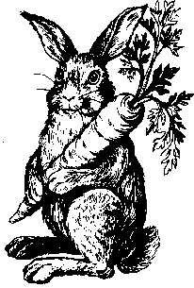

Driving Directions:
From the South and Northwest: I-65 to Exit #168 (HWY 38) go west from the interstate exit, passing SIA auto plant to Sagamore Parkway (HWY 52). Turn left onto Sagamore Parkway, go 1/2 mile to Teal Road (stoplight and BW3 Bar and Grill), turn right onto Teal and go 2 miles and enter fairgrounds on your right. Swine barn off to the left.

From the Southwest: Take US 231 or HWY 25 to Lafayette. At the intersection of US 231 (four land section) and HWY 25 take old 25 east into Lafayette turning left on old 231 and 4th street. At Carter Lumber and old 231/4th street turn left and travel about 1 mile to a stoplight at the bottom of the hill. Teal Road intersects at this stoplight. Take Teal Road right about 1 1/2 miles and turn left into the fairgrounds. Swine barn will be off to the left once you enter the fairgrounds.

From the West and Northwest: Bring HWY 26 or HWY 43 into West Lafayette and follow US 231 south across the Wabash River until you come to a stoplight and the intersection of US 231/HWY 25 & 43. Turn left or east onto old 25 traveling to old 231 and 4th street (Carter Lumber), turn left and travel about 1 mile to a stoplight at the bottom of the hill. Teal Road intersects at this stoplight. Take Teal Road right about 1 1/2 miles and turn left into the fairgrounds. Swine barn will be off to the left once you enter the fairgrounds.

From the East: Bring HWY 26 or HWY 28 to I-65. HWY 26 go south on I-65 and HWY 28 go north onto I-65. At exit #168 (HWY 38) go west from the interstate exit, passing SIA auto plant to Sagamore Parkway (HWY 52). Turn left onto Sagamore Parkway, go 1/2 mile to Teal Road (stoplight and BW3 Bar and Grill), turn right onto Teal and go 2 miles and enter fairgrounds on your right. Swine barn off to the left.

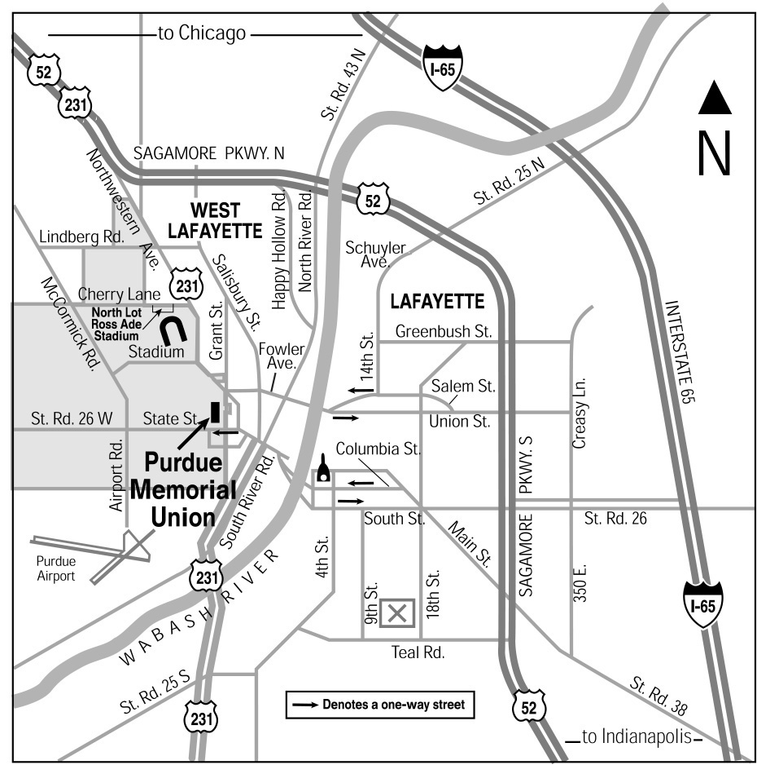

Fairgrounds are located at 1401 Teal Road, between 9th and 18th Streets.

Golden Prairie RBA
Karen Poe, Club Secretary
1813 Melbourne Rd.
Lafayette, IN 47904

FIRST CLASS MAIL

